Clean Desk Policy
Directions: Look at the picture of the desk below. List at least five items that should not be left out when the person leaves the desk.
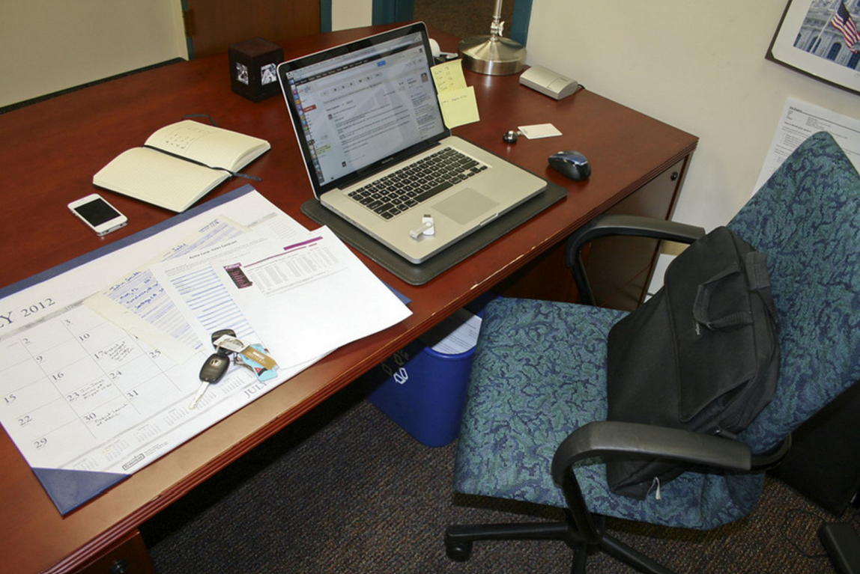

1.
2.
3.
4.
5.

